

Under the Guidance of
Mr. Soumik Karmakar

SESSION: 2025-26

Submitted By
KUSHAL KUMAR
Reg No.RU-25-10735

RUNGTA INTERNATIONAL SKILLS
UNIVERSITY
BHILAI ,
CG
File Compression Simulator

(
Using Core Java & OOP Concepts
)
RU-100-01-00012

Object Oriented Programming With Java
Project Interim Report

On
Bachelor of Technology in Computer Science &
Engineering with AI and ML in association with Google
SCHOOL OF COMPUTER SCIENCE AND E
NGINEERING

(
April
2026)
Abstract
The Library Management System is a software application developed using Object-Oriented Programming (OOP) concepts in Java. This project is designed to manage book records efficiently and automate basic library operations such as searching, issuing, and returning books. Traditionally, libraries maintain records manually, which is time-consuming and prone to errors. This system reduces manual work and improves accuracy.
The project maintains details of books including title, author, and availability status. It allows users to search for books, check availability, issue books, and return them. The system dynamically updates the availability of books based on user actions.
The main aim of this project is to demonstrate the use of OOP principles such as classes, objects, encapsulation, constructors, and arrays of objects in solving real-world problems. This system is simple, efficient, and user-friendly, making it suitable for small-scale library management.

Introduction
The Library Management System is developed to simplify the process of managing books in a library. In traditional systems, all records are maintained manually, which increases the chances of errors and inefficiency.
This project uses Java and OOP concepts to create a structured and modular system. It includes two main classes: Book and Library. The Book class stores individual book details, while the Library class manages a collection of books.
✨ Features:
- Store book details (title, author, availability)
- Search books by title
- Issue books
- Return books
- Display all books
- Dynamic status update
This system ensures better organization, faster operations, and easy maintenance.

Scope
This project is suitable for small libraries such as school or personal libraries. It can be extended in the future by integrating:
- Database (MySQL)
- GUI (Java Swing)
- Online access system

System Requirements
💻 Hardware:
- Computer with minimum 4GB RAM
🖥 Software:
- Java JDK
- IDE (VS Code / Eclipse / EditPlus)

Methodology
The working of the system follows these steps:
- Initialize the library with some books
- Display menu options to the user
- User selects an operation:
  - Display books
  - Search book
  - Issue book
  - Return book
- System processes the request:
  - Searches book in array
  - Updates availability status
- Output is displayed to the user
- Loop continues until user exits

Flowchart
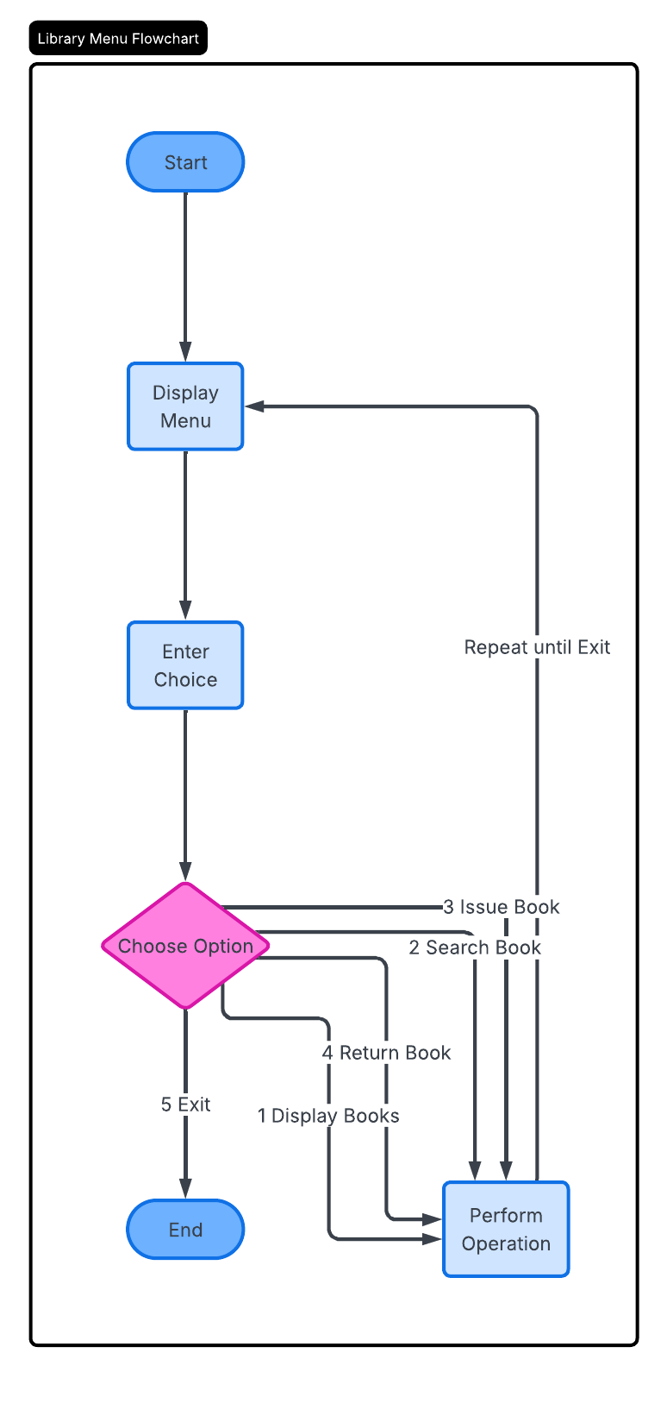

Implementation
📘 Book Class:
This class represents a single book. It stores book details such as title, author, and availability status. It uses encapsulation by keeping variables private and providing getter/setter methods.
📘 Library Class:
This class manages multiple books using an array of objects. It includes methods to:
- Display all books
- Search for a book
- Issue a book (if available)
- Return a book
📘 Main Class:
This class provides a menu-driven interface using Scanner. It takes user input and calls appropriate methods from the Library class.

Gantt Chart
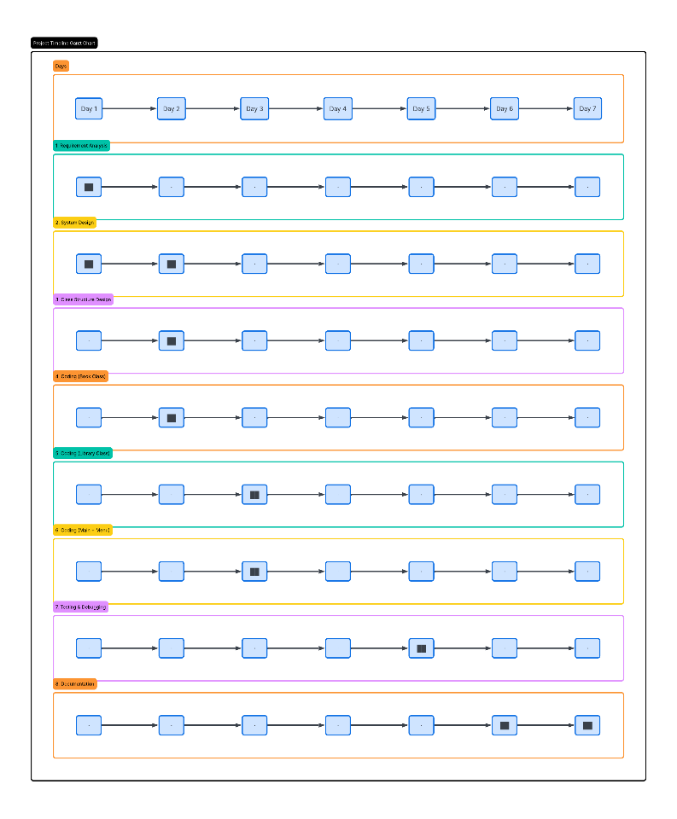
Conclusion
The Library Management System successfully demonstrates the use of Object-Oriented Programming concepts such as classes, objects, encapsulation, and arrays. It provides a simple and efficient way to manage library operations like issuing and returning books. The project is user-friendly and reduces manual effort, making it useful for small-scale applications.

References
Book
[1] H. Schildt, *Java: The Complete Reference*, 11th ed. New York: McGraw-Hill, 2018.

[2] E. Balagurusamy, *Programming with Java: A Primer*, 6th ed. New Delhi: McGraw-Hill Education, 2019.
Website
[3] Oracle, "Java Documentation," Oracle. [Online]. Available: https://docs.oracle.com

[4] GeeksforGeeks, "Object-Oriented Programming in Java," GeeksforGeeks. [Online]. Available: https://www.geeksforgeeks.org
Conference Paper
[5] S. Kumar, "Software Systems in Education," in Proc. IEEE Conf. on Computing, 2021, pp. 120-125.
Example:
[1] H. Schildt, *Java: The Complete Reference*, 11th ed. New York: McGraw-Hill, 2018.
Journal Article
[6] A. Sharma and R. Gupta, "Object-Oriented Programming Techniques," International Journal of Computer Science, vol. 5, no. 2, pp. 45-50, 2020.

